**MIS4084: SQL Queries**

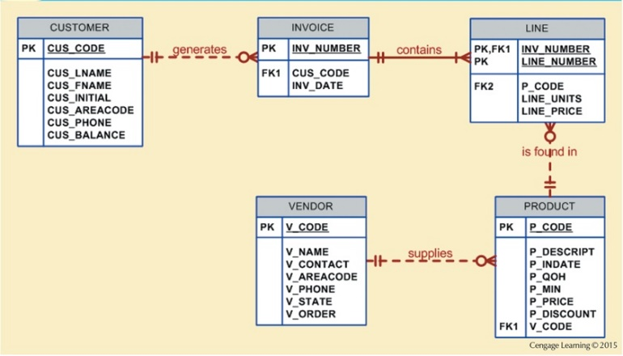

1. Which customers live in the area code 01609? (First and last names)
   1. How much is their total balance?
2. How many customers living in the area code 01609 have a balance greater than $1,000?
3. How many customers had a sales transaction on February 2, 2021?
4. How much was the total sales on February 2, 2021?
5. How many customers have purchased a DELL product in Q4 2019?
6. How many DELL products have we sold in Q4 2019?
7. In 2020, which vendors did customer #1204 purchase at least one product from? List the vendor names.